Machine Learning Assignment 1
20248224
Soongsil University
2150534602머신러닝
Dr 유용석
May 2, 2025

Summary
This project aimed to predict the next day’s KOSPI closing price using machine learning regression techniques on historical market data. This project has two parts.
In Part 1, models were trained using the provided basic features, “Open”, “High”, “Low”, “Close”, and “Volume” from 2019-2022. The test data came from 2023-2024 A baseline linear regression model using only the “Open” feature performed poorly (MSE: 328.92). A multi-featured linear regression significantly improved accuracy (MSE: 56.66), and further improvement was achieved by removing the statistically insignificant “Volume” feature (MSE: 56.51).
In Part 2, additional features were incorporated, notably the KRW/USD exchange rate from FRED. Although its inclusion slightly reduced MSE to 56.21, statistical analysis showed a high p-value and lower F-statistic, indicating weak independent predictive power. A regression decision tree was also tested but yielded poor performance (MSE 324.23) and long training time, reinforcing that linear models are more appropriate for continuous financial data.
Overall, the best-performing and most efficient model was the multi-feature linear regression using “Open,” “High,” and “Low.” It balanced prediction accuracy and model simplicity while demonstrating strong statistical significance. This suggests that while additional economic indicators like exchange rates may provide marginal gains, they do not necessarily enhance the model’s robustness.
Introduction
The Korea Composite Stock Price Index (KOSPI) is a benchmark that reflects the overall performance of the South Korea’s stock market. It is used by investors, policymakers, and analysts to predict economic outlook and market sentiment in South Korea. Accurate prediction of the Stock market is of significant interest, as it can support decision-making in government policy, risk management, and market trading.
Stock market prediction is a challenging task due to the inherently noisy, non-stationary, and complex nature of financial time series data. Despite this, advances in machine learning have enabled the development of powerful models capable of capturing patterns in historical data to make short-term forecasts. This project uses machine learning regression techniques to predict the next day’s KOSPI closing price based on historical market data.
This project is divided into two parts. In Part 1, basic market data is supplied from kopsi_train.csv and kopsi_test.csv. These data sets have features such as Open, High, Low, Close, and Volume. These features are then used to predict the next day’s closing price. Then multiple regression models are trained and compared using Mean squared error to identify the most effective approach. In Part 2, more data is explored to improve prediction accuracy by incorporating additional publicly available statistics. The South Korean won to American Dollar exchange rate from FRED was the publicly used statistics for this part.
The objective is to evaluate the performance of different regression models and assess the prediction accuracy. Through this, insights can be gained into the potential for predicting future KOSPI data.
Methods
Data
The dataset provided for this project contains daily KOSPI data from 2019 to 2022, including the features Open, High, Low, Close, and Volume. These features were used as the predictors for predicting the next day's KOSPI closing price for part 1.
For part 2 another feature was added. The feature added is the exchange rate of the Korean Won (KRW) to US Dollars, sourced from the Federal Reserve Economic Data (FRED) website. This feature was included to capture potential influences of currency fluctuations on the KOSPI index.
Some days in the dataset had missing values (NaN)s for the exchange rate. Since linear regression requires completed data these missing values were replaced by averaging the exchange rates of the previous and next available days. This allowed the data to be used however this could’ve introduced error into the results
Model Selection and Training
In Part 1, the objective was to predict the next day's closing price of KOSPI based on historical market data. Initially, Linear Regression was used. The first model used only two features: Open and Close. This baseline model aimed to predict the next day's Close value based on the current day's Open. Its RSE was 328.92 and the graph can be seen in Figure 1
In the next models Multiple Feature Regression was used to improve the predictions by including additional features: Open, High, Low, Close, and Volume. This extended model allowed for a more complex relationship to be modelled
A regression decision tree model was also implemented using the same features as to explore non-linear patterns in the data. The tree was trained on the 2019–2022 data with default parameters using scikit-learn. However due to the difficult in modelling continuous data with a tree as a tree is more of a step by step and cannot create smooth transition model this method was discarded as it took to long to train and had a super high error rate.
The models were evaluated using Mean Squared Error (MSE), and the best-performing model was selected. The final model included Open, High, and Low while excluding Volume. Although the difference in MSE between models was only 0.15, which was considered negligible, the simpler model without Volume was selected due to its comparable performance and reduced complexity. The RSE of the 2 best was 56.51 without volume and 56.66 with volume. They can be seen in figure 2 and 3 respectively
External Features in Part 2
For Part 2, additional publicly available data was incorporated to improve model performance. In addition to the exchange rate feature (KRW/USD), other global economic indicators that could influence the KOSPI index were included. These external indicators were sourced from FRED and other publicly accessible databases. The data was merged with the original KOSPI dataset based on the date, ensuring that both market features and external indicators were aligned.
Model Evaluation
Mean Squared Error (MSE): Quantified the average squared difference between predicted and actual closing prices.
R² Score (Coefficient of Determination): Measured how well the model explained the variance in the target variable.
t-statistics and p-values: These were calculated for each predictor to assess statistical significance. A high absolute t-value and a low p-value indicate strong evidence that a predictor contributes meaningfully to the model.
The models were compared based on their performance on a test set.
Results
Firstly for the baseline model linear regression with only two features. It used the “Open” feature to predict the “Close” value. Single feature linear regression was used on training data with inputs “Open” and “Close” The resulting SME was 328.92. and the predictions can be seen on figure 1 comparing the predicted values to the real values. 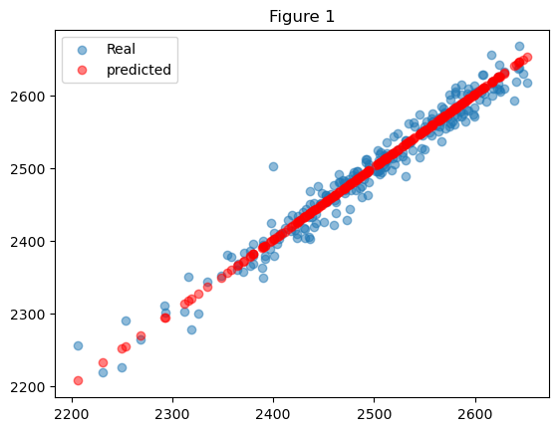
The next step was to include all Features available using Multi feature regression. This had features such as “Open”, “High”, “Low”, and “Volume”. By including all features a significant decrease in MSE was seen from 328.92 to 56.66. This can be seen in figure 2.
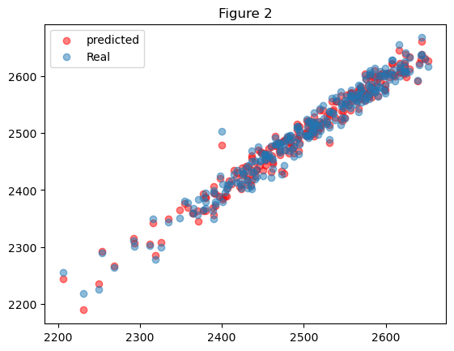
An Ordinary Least Squares (OLS) regression was applied, yielding an R² score of 0.99, indicating an excellent fit between the model and the data. The F-statistic was 4.848e+05, confirming that the model is statistically significant. Among the predictors, “Open,” “High,” and “Low” all returned low p-values, demonstrating that they are statistically significant to the prediction of the target variable. In contrast, “Volume” had a high p-value of 0.341, suggesting it is not a significant predictor. As a result, the “Volume” feature was removed in the subsequent model to improve model efficiency and performance. The results can be seen in Figure 3.
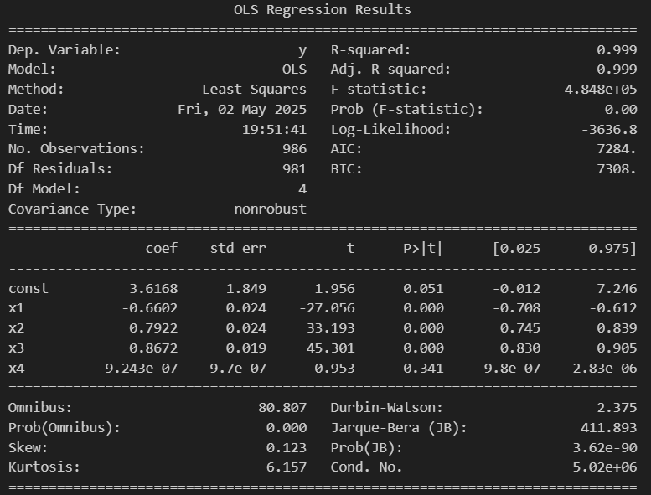
Figure 3
In the next model, the “Volume” feature was removed, resulting in a simpler model with fewer features. This change led to an improvement in prediction accuracy, with the Mean Squared Error (MSE) decreasing from 56.66 to 56.51. The reduction in MSE indicates that removing “Volume” had a positive effect on the model’s ability to generalize to unseen data.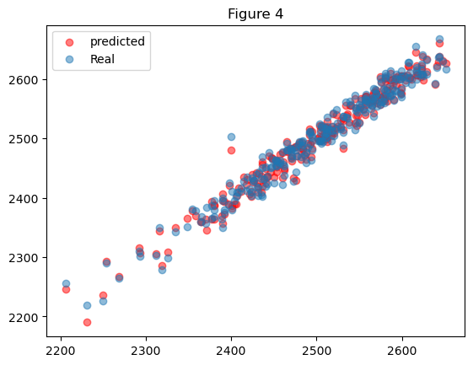
In addition to the improved MSE, the F-statistic increased significantly to 6.464e+05. This indicates a stronger overall model fit and suggests that the remaining predictors explain a greater proportion of the variance in the target variable.
Lastly, the decision to exclude “Volume” is supported by its high p-value in earlier models, confirming that it was not statistically significant. This reinforces the idea that “Volume” did not contribute meaningful predictive value and may have introduced unnecessary noise. The results can be seen Figure 5.
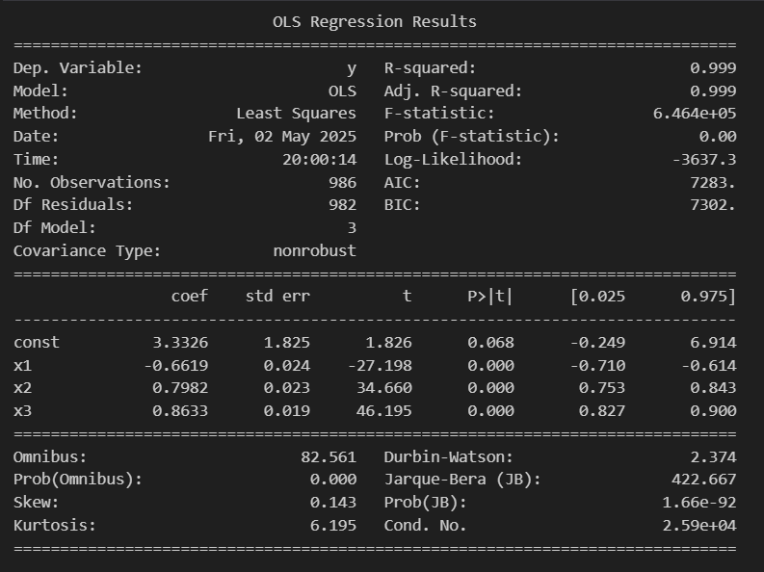
Figure 5
Moving onto the results of Part 2. A further feature was added to. The feature added it the exchange rate between Korean won (KRW) and the United states Dollar (USD). So the feature set of this model was “Open”, “High”, “Low” and “Exchange”. The data was taken from FRED (Federal Reserve Economic Data) however, some dates contained missing values ("NaN"). So they were replaced with the average of the previous and next day data. This may have added some error into the results. However the new MSE decreased from 56.51 to 56.21 showing a minor increase in accuracy prediction but not a major increase. The difference is however more significant than the removal of volume. As in testing with the “Volume” feature added back the MSE was still reduced to 56.39. Showing that this choice of data was significant and had impact on the improving the prediction of “Close” Value. The data can be seen in Figure 6
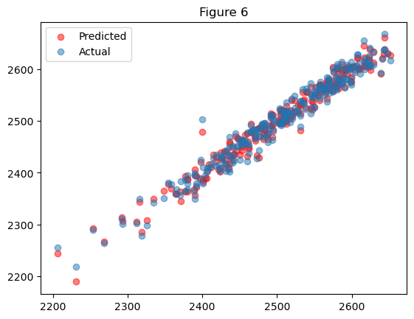
However, in Figure 7 we can see that the F-statistic has decreased, and x4 ("Exchange") has a high p-value (0.419), indicating it is not statistically significant. This suggests that although the inclusion of the exchange rate marginally improves the overall model accuracy evidenced by a lower MSE it does not meaningfully contribute as an independent predictor. In other words, the exchange rate appears to correlate with the target variable but does not exert a statistically significant effect when compared with other Features. Overall, while the exchange rate improves model stability and slightly enhances predictive accuracy, its lack of significance suggests it should be used cautiously and may not be essential for the model. The data can be seen in Figure 8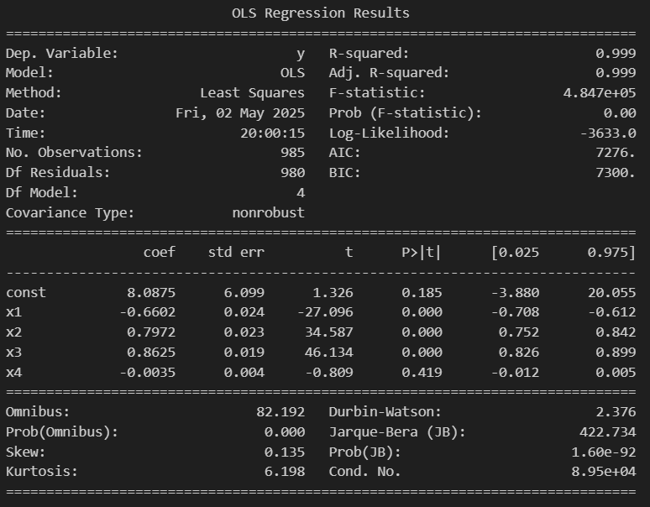
Figure 8
Lastly, a regression decision tree was implemented. its performance was suboptimal. The model had a Mean Squared Error (MSE) of 324.23, only a slight improvement over the baseline, and significantly worse than the Multi-linear regression models. Additionally, it required approximately 66 seconds to train. So it was computationally expensive.
Regression trees often struggle with financial time series data due to their tendency to overfit they split the data into increasingly specific rules that can capture noise rather than meaningful trends. Unlike linear models, which assume a consistent relationship across the dataset, trees attempt to segment the data, which works poorly when the data is a continuous trends. As a result, decision trees typically offer limited generalization in financial predictions.
This reinforces the conclusion that linear models are more effective and efficient for this particular prediction task. The tree can be seen below in Figure 9.
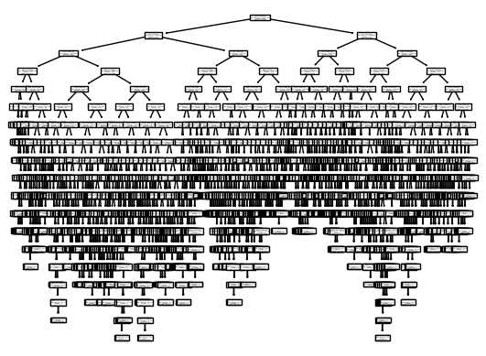
Figure 9
Discussion
The decision to explore the KRW/USD exchange rate as a feature was motivated by its historical and economic relevance. The U.S. dollar, formerly tied to the gold standard, once served as a global reserve currency influencing other currencies, including the Korean won. In theory, exchange rate fluctuations could reflect macroeconomic pressures impacting the KOSPI index. However, while its inclusion offered a minor reduction in MSE, its high p-value and reduced F-statistic indicates it is not a robust standalone predictor. Thus it does not significantly enhance the model's statistical strength and should be considered carefully when included.

Conclusion
In this project, several regression models were explored to predict the KOSPI closing value using a variety of financial indicators. The baseline model, which used only the "Open" price, performed poorly with an MSE of 328.92. Using additional features such as “High,” “Low,” and “Volume” significantly improved performance, reducing the MSE to 56.66. Then through OLS regression analysis “Volume” was revealed to not be a statistically significant predictor, and was removed. By the removal of “Volume” MSE was further reduced to 56.51, whilst also improving model simplicity and computational efficiency.
The introduction of the KRW/USD exchange rate as a feature led to a marginal improvement in MSE (down to 56.21), but the feature’s high p-value and corresponding drop in the F-statistic suggest it lacks strong predictive power on its own. While economically relevant, it did not serve as a statistically reliable feature in this model.
A regression decision tree was also tested but failed to outperform the linear models, achieving a much higher MSE of 324.23 and requiring significantly more computational time. This supports the conclusion that tree-based models are less suitable for continuous financial trend data, where linear relationships provide better generalization.
Overall, the best-performing model was the multi-feature linear regression using “Open,” “High,” and “Low.” This model achieved a balance between statistical significance, predictive accuracy, and computational efficiency, making it the most suitable approach for forecasting KOSPI closing prices in this context.

References
Federal Reserve Bank of St. Louis. (n.d.). FRED: Economic data. https://fred.stlouisfed.org
GeeksforGeeks. (2024, May 15). Mean squared error: Definition, formula, interpretation, and examples. GeeksforGeeks. https://www.geeksforgeeks.org/mean-squared-error/
Hunter, J. D. (2007). Matplotlib: A 2D graphics environment. Computing in Science & Engineering, 9(3), 90–95. https://doi.org/10.1109/MCSE.2007.55
Harris, C. R., Millman, K. J., van der Walt, S. J., Gommers, R., Virtanen, P., Cournapeau, D., ... & Oliphant, T. E. (2020). Array programming with NumPy. Nature, 585(7825), 357–362. https://doi.org/10.1038/s41586-020-2649-2
McKinney, W. (2010). Data structures for statistical computing in Python. In S. van der Walt & J. Millman (Eds.), Proceedings of the 9th Python in Science Conference (pp. 51–56).
OpenAI. (2025). ChatGPT [Large language model]. https://chat.openai.com/chat
Pedregosa, F., Varoquaux, G., Gramfort, A., Michel, V., Thirion, B., Grisel, O., ... & Duchesnay, É. (2011). Scikit-learn: Machine learning in Python. Journal of Machine Learning Research, 12, 2825–2830.
Seabold, S., & Perktold, J. (2010). Statsmodels: Econometric and statistical modeling with Python. In Proceedings of the 9th Python in Science Conference.
W3Schools. (n.d.). Python Machine Learning Decision Tree. W3Schools. https://www.w3schools.com/python/python_ml_decision_tree.asp
W3Schools. (n.d.). Python Machine Learning Linear Regression. W3Schools. https://www.w3schools.com/python/python_ml_linear_regression.asp
W3Schools. (n.d.). Python Machine Learning Multiple Regression. W3Schools. https://www.w3schools.com/python/python_ml_multiple_regression.asp
W3Schools. (n.d.). Python Machine Learning Scatter Plot. W3Schools. https://www.w3schools.com/python/python_ml_scatterplot.asp
‌

